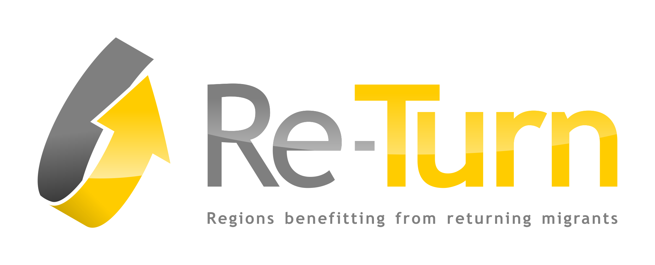

Analysis Sub-sample East-Germany

Description of Sample

Populations

Frequency sample East-Germany
 |  | Frequency | Valid per Cent
Total | Potentials | 244 | 62,7
 | Returnees | 145 | 37,3
 | Total | 389 | 100

- Def. Potentials: These are emigrants who currently live abroad or in West-Germany.
- Def. Returnees: These are East-German return migrants who have moved back to East-Germany after they had been abroad or in West-Germany for at least 6 months.

- Def. “Stayer’s”: Potentials without considerations to go back to East-Germany.
- Def. “Maybe’s”: Potentials who consider to go back to East-Germany.
- Cf.: chapter 2.1.

Destination regions of Returnees

Migration status
 |  | Frequency | Valid per Cent
Valid | Region Returnee | 107 | 73,8%
 | Country Returnee | 38 | 26,2%
 | Total | 145 | 100,0%

- Def. Region Returnee: These are East-German return migrants who have moved back into their former home region in East-Germany.
- Def. Country Returnee: These are East-German return migrants who have moved back into a different region than their home region within East-Germany.

Home regions

Age

- Returnees aren’t significant younger than Maybe’s and Never’s.

Education

- There are significant differences concerning the Education level Returnees have a higher level than Maybe’s and Stayer’s.

Gender

- The East-Germany sample consists of more women than men (~57% women vs. ~ 43% men).

Family status

Children

Thematic Analysis

Emigration Motives
„How important was it to improve the following factors when you decided to move abroad?”

- For all three groups the most important motives to emigrate were the career opportunities and the income improvement.
- There are no statistically significant differences between the groups in the importance of most motives.

Employment after emigration and after return
„What was your employment situation abroad after emigration/at home after return?“

Income
„What about your average monthly household income before emigration, after emigration and after return?“

„How good could you live on your income before emigration, after emigration and after return?“

- Both real and subjective income reveals no statistically significant differences between the groups.

Job adequacy after emigration
„While being abroad, were you working in a relatively/completely new professional field compared to your previous jobs or education?“

Migration flows

- EU (new member states) = since 2004 in the EU integrated states

Intention to stay abroad
„Before your emigration, how long did you intend to stay abroad?“

- Stayer’s and Maybe’s were more vague in their intended length of stay abroad.
- More than the half of the Returnees intended to stay five years or less.

Acceptance in host country
„Returnees: How much did you feel being accepted as a member of the society in your host country abroad?“
„Stayer’s and Maybe’s: How much do you feel being accepted as a member of the society in your host country?“

- There exist significant differences between the three groups Stayers feeling more accepted in host country/West-Germany (~90% completely or very much) than Maybe’s and especially Returnees (just 59% felt completely or very much accepted).

Number and origin of people whom the leisure time was spent with in host country after emigration & in home country after return

„With how many people did respectively do you spend your leisure time in your host country?“

- Stayer’s have significant more often networks with hosties and others could be an evidence for the better integration in the host society.

Appreciation of skills brought from home country to host country (after emigration) & from host country to home country (after return)
„How open-minded are/were people in your professional environment towards knowledge and skills that you brought from home?”

Satisfaction in host country
„Returnees: How satisfied have you been with the following factors abroad once you had moved there?“
„Potentials: How satisfied are you today with the following factors abroad?“

- Potentials are statistically significantly more satisfied with the family situation und the social benefits system in the host country.

Consideration to return
„Potentials: Do you consider going back to your home country?“

- Potentials with considerations to return to East-Germany “Maybe’s”
- Potentials without considerations to return to East-Germany “Stayer’s”
„Do you consider going back to your home region?“

Plans to return
„Maybe’s: Have you already made plans for your return?“

Expected difficulty of return
„Returnees: How easy was it for you to return home?“
„Maybe’s: How easy do you expect the return to be?“

„Maybe’s (those who expect the difficulty of return very difficult or difficult): Which factors do you expect to make the return difficult?“

- The labor market at home in East-Germany is expected as the aspect to make a potential return the most difficult.

Acceptance of worse working conditions
„Maybe’s: Would you accept worse working conditions (e.g. a lower salary, a less skilled position, a different profession) in order to realize your wish to return to East-Germany?“

- ~54% of those Potentials who indicate a positive consideration to return to East-Germany would also accept worse working conditions at home.

Motivation to stay abroad vs. motivation to return
„Returnees: How important are the following factors in your decision to move back to East-Germany?“
„Maybe’s: How important is it for you to improve the following factors with your return to East-Germany?“
„Stayer’s: What factors are important in your decision to stay abroad?”

- For Stayer’s are the “life general”, the “career opportunities” and the “income” the most important aspects for their decision to stay abroad/ in West-Germany.
- For Maybe’s and Returnees is the “proximity to friends” one of the most important aspects for decision making. Returnees cherish this aspect less regard.

Knowledge about return initiatives
„Returnees: Did you know about any initiative/support service/agency in East-Germany assisting your return?“
„Potentials: Do you know about any initiative/support service/agency in East-Germany assisting your return?“

- There is a significant difference between the Returnees and Potentials regarding their knowledge about return initiatives could depend on learning effects after return.

Maintenance of a household at home
„Returnees: I maintained a household in East-Germany while living abroad“
„Potentials: I am maintaining a household in East-Germany while living abroad.“

Knowledge of other Returnees
„How many people do you know that have returned to East-Germany from abroad?“

- There is a high statistically significant difference between the groups. Returnees know more other Returnees than Stayer’s (over 60% of the Stayer’s know no or just one Returnee).

- Maybe’s and Returnees know compared to Stayer’s statistically significant more potential Returnees.

Place of meeting partner
„Where have you met your partner?“

- There is a statistically significant difference between the groups concerning the place of meeting partner. Returnees (~67%) and Maybe’s (62%) having met their current partner most often in the home region. More than half of the Stayer’s met him/her in the host region.

Modes of connecting to home country

„How did/do you connect to East-Germany during your stay abroad?“

